Multi-Paradigm Programming Shop Assignment

This report compares the solutions achieved using the procedural approach and the object-oriented approach when completing the shop assignment. The python programming language was used for both programming paradigms as shown in Figure 1 and Figure 2.

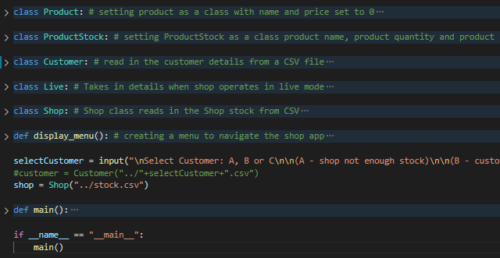

Figure 1 object-oriented implementation

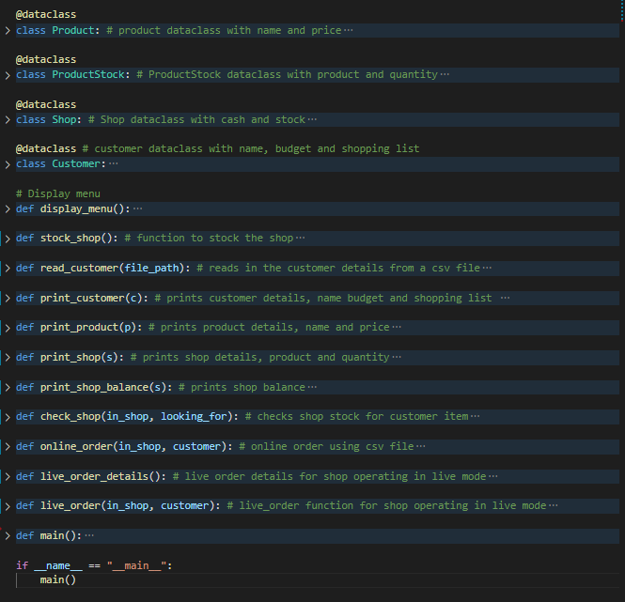

Figure 2 procedural implementation

With reference to Figure 1 everything except the menu is an object. In total there are 5 objects. In the object-oriented implementation the class of the object has both state and functionality, unlike the procedural implementation which only has state. Consider Figure 3 and Figure 4 below

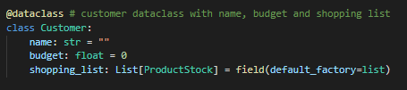

Figure 3 Customer class in procedural

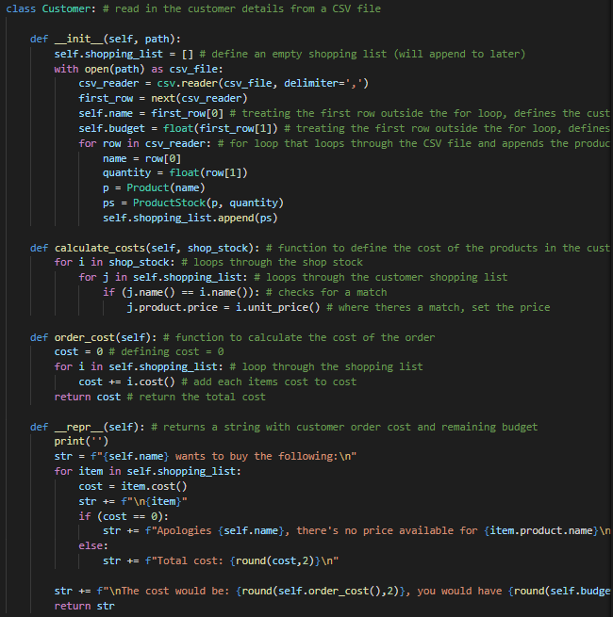

Figure 4 Customer class in object oriented

With reference to Figure 3 and Figure 4, in the procedural implementation the Customer class contains the state only (name, budget and shopping list), whereas in the object-oriented implementation the Customer class contains the state and functionality. The functionality reads in the customer details from a csv file, calculates the costs and outputs information.

Considering that Customer is a class, or template there can be many instances of it. In the shop assignment there are 3 instances of customer. Each of the 3 customers have different names, budgets, and shopping lists but all 3 use the Customer class.